UNU-IRADDA Setup – D1

TableSet ID | TableSet ID Definition
Navigation:  PeopleTools > Utilities > Administration > TableSet IDs | 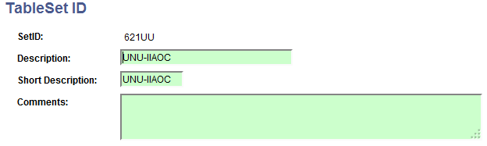

Payables | AP BU Definition
Navigation:  Set up Financials/Supply Chain > Business Unit Related > Payables > Payables Definition | 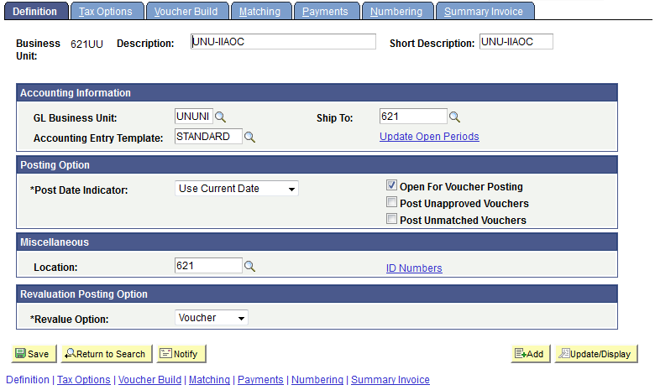
Navigation:  Set up Financials/Supply Chain > Business Unit Related > Payables > Payables Options | 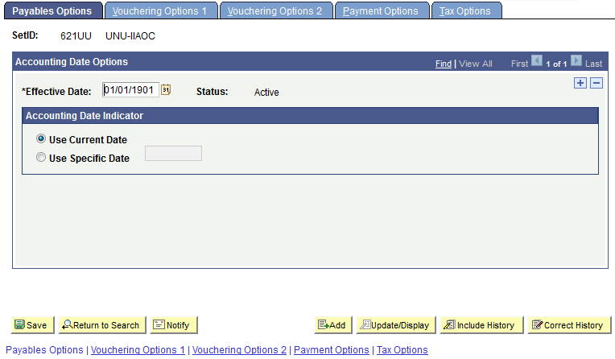

Purchasing | PO BU Definition
Navigation:  Set up Financials/Supply Chain > Business Unit Related > Purchasing > Purchasing Definition | 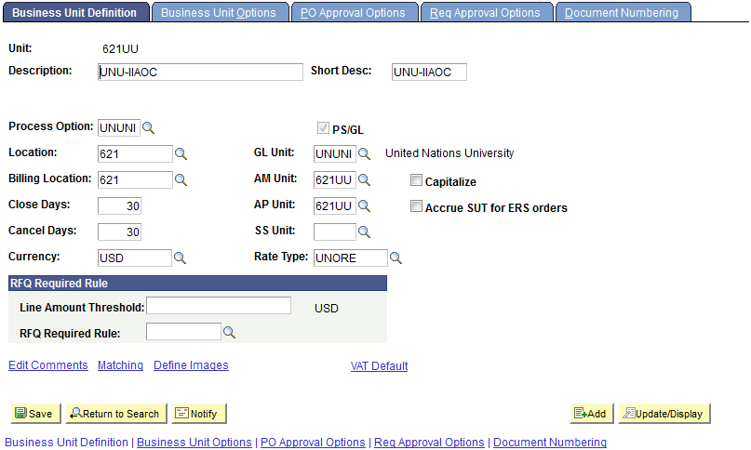

Receivables | AR BU Definition
Navigation:  Set up Financials/Supply Chain > Business Unit Related > Receivables > Receivables Definition | 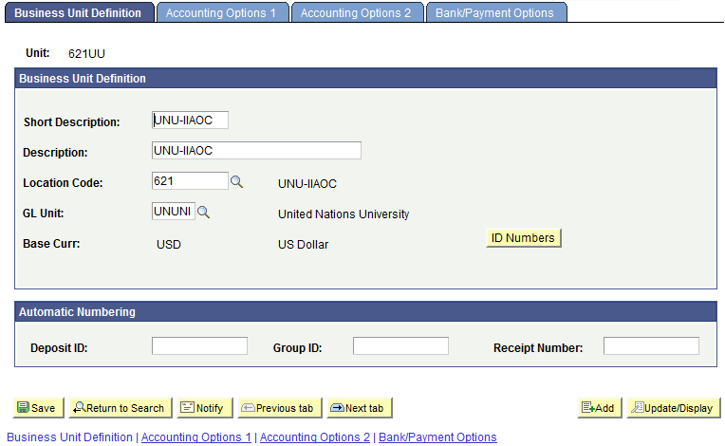

ChartFields | CF Definition
Navigation:  Set up Financials/Supply Chain > Common Definitions > Design ChartFields > Define Values > ChartField Values > Operating Unit | 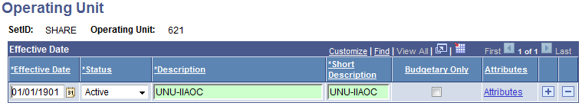
Navigation:  Set up Financials/Supply Chain > Common Definitions > Design ChartFields > Define Values > ChartField Values > Department | 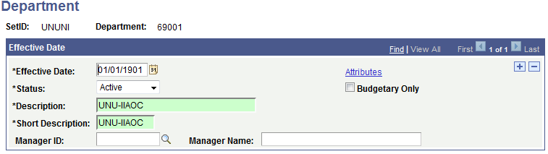  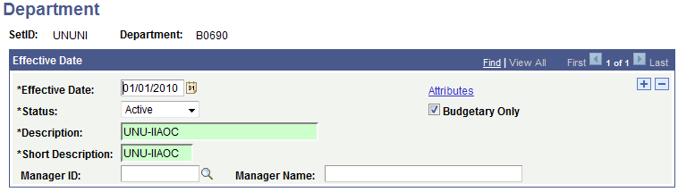

Location | Location Definition
Navigation:  Set up Financials/Supply Chain > Common Definitions > Location > Location | 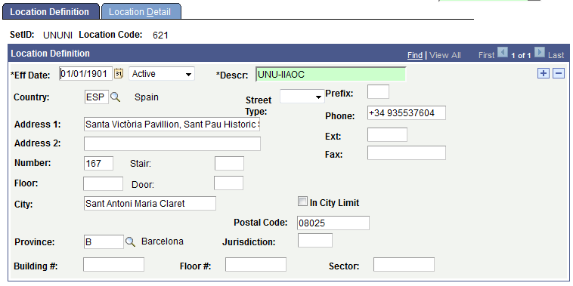  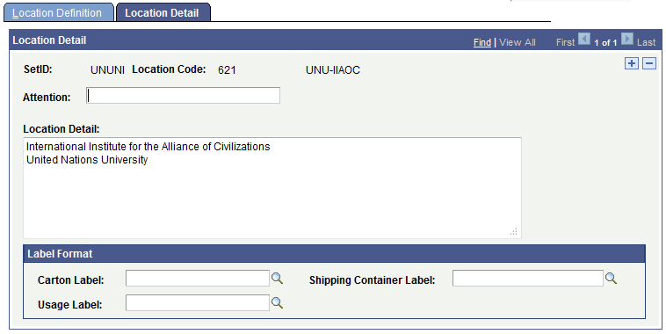

Ship To Location | Ship To Locations Definition
Navigation:  Set up Financials/Supply Chain > Product Related > Procurement Options > Purchasing > Ship To Locations | 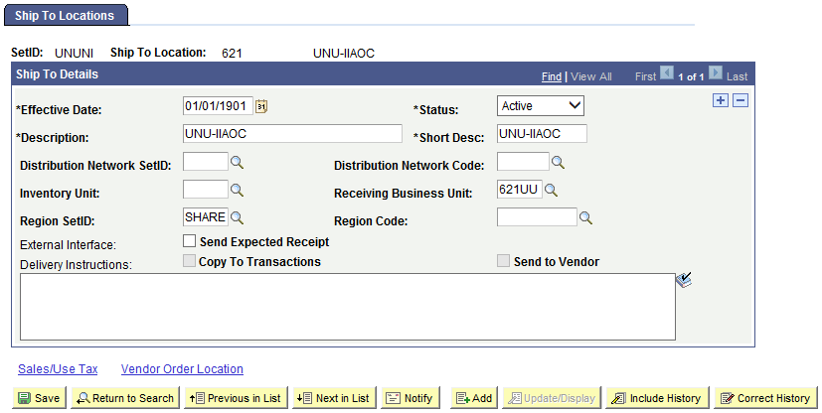

Institutions | Institution Definition
Navigation:  Grants > Institutions > General Information | 